TASK-3

* **Dark store** refers to a retail distribution center or outlet that caters exclusively to online shopping.
* Dark stores get their name from being dark – that is, closed to the public, since they are only used to fulfill online orders.
* Customers are given the option of not having to go to the supermarket to pick up items and pay. Everything they have to do is place an order online and have it delivered to their house.
* Dark stores concentrate on internet order delivery in high-demand locations. For retailers in large geographical regions and areas, the presence of dark stores is important.
* A large warehouse that can either be used to facilitate a collect-and-click service whereby a client collects an item that they have ordered online or an order fulfillment platform for online sales.
* The rise in e Commerce and a decline of in-store purchasing predated Covid , but the pandemic occasioned a surge in growth that now has many businesses re-evaluating their use of retail space.
* Dark stores do use physical outlets, but these spaces are e Commerce warehouses, distribution centers or micro-fulfillment hubs.
* More common in the grocery and whole food sectors, dark stores are becoming increasingly prevalent in fashion, big box retail and the home ware & furniture industries.
* Retailers will set up a dark store to fulfill consumer needs and respond to consumers at all contact points in real-time.
* Dark stores aided merchants with physical locations in providing contactless distribution and pickup alternatives for their customers.
* Dark stores and micro-fulfillment centers are on course to become a retailer’s core strategy for solving supply chain vulnerability. Five of the many benefits offered by using dark stores include:
* Dark store order processing is much like the steps taken for warehouse order fulfillment, however on a smaller scale:

1. Online orders are received and processed.
2. Orders are electronically sent to the shop floor.
3. Employees pick orders displayed on a digital screen attached to their shopping trolley.
4. Multiple orders can often be collected simultaneously.
5. Orders are packed and shipped.

**ADVANTAGES**

### **Dark stores enable fast and contact-free shopping**

### **Distribution and delivery are more efficient with dark stores**

### **Dark stores have more products and a larger audience**

### **A better view of stock levels**

### **Inventory control is enhanced with dark stores**

* Additional Capacity
* Full Range of Items
* Great Availability
* Increased Efficiency
* Enhanced Quality
* Improved Picking Accuracy
* 24/7 Operation
* Centralized Route Planning
* Opportunities for New Goods

**The SKU Challenge:**

* Dark Stores can improve SKU(Stock-Keeping Units) management in a variety of ways by focusing on storage and click-and-collect capabilities. One, they save money on real estate by avoiding high-traffic areas in cities. Two, they will serve many online grocery stores at the same time, reducing real-estate costs.
* The ability to improve SKU control improves distribution accuracy and avoids mix-ups.

**The Perishability Challenge:**

* It necessitates flawless warehouse control, product replenishment, and order fulfillment – all of which must work to minimize the time between off-the-store-fridge and in-the-home-fridge.
* To put it another way, supermarket fulfillment necessitates pickers working at a high rate, which is difficult to do in a typical discount grocer where aisles are clogged with leisurely shoppers gliding around in their shopping carts.

# Four Ways to Manage Dark Store Inventory

* Seasons are changing, trends are evolving, and customer preferences are changing with in a period of time. As stores reopen, brands still have a responsibility to get their inventory out on the floor and into the hands of shoppers.
* The retail industry’s paradigm is shifting, and retailers need to focus their strategies and operations on the road ahead – that includes leveraging new innovations, understanding customer expectations, and managing a backlog of inventory.
* The retailers should consider the following methods to maintain a balanced and a profitable dark stores:

1. **Having Enough Inventory:**

* It will take time for stores to fully restock and for businesses to get accustomed to the new reality.
* The strategic planning, precise execution, and up-to-date technology, stores can properly allocate current backroom stock. For orders that have not been canceled, it is imperative to consider a location strategy.
* Location plays a critical role in inventory based on consumers’ preferences and trends, since what is trendy in one place is different than in other place.

1. **Disrupted Data:**

* The partial data disrupts the accuracy of retailers’ understanding of customer preferences, potentially leaving them with incomplete information when they look to identify trends for future seasons.
* details from online order fulfillment, online shopper demographics, and curbside pickup location information can help fill in the gaps.
* retailers can better anticipate how consumers will behave in the future. With contextual intelligence about their customers garnered from first- and third-party data, retailers can also better predict shifts in demand, location preferences, and short- and long-term sales trends.

1. **Here, There or Where?**

* Understanding the most effective channel or location to place distressed inventory can be a crucial challenge.
* Retailers must decide if it is more advantageous to shift stock out of idle locations to another store or channel but potentially price it differently than they might in-store.
* Retailers must create new location planning processes to ensure inventory is in the right stores to recoup maximum sales and margin at the time of reopening.

1. **Profiting in the Months Ahead:**

* It is integral to place guardrails around current strategies and plans to understand future margin risks and opportunities.
* Retailers should consider hypothetical, what-if situations and challenges to help determine the best price point for each item. Every channel and location poses its own unique potential challenges and rewards, so it is essential for brands to run different scenarios to understand how to profitably place inventory.
* Utilizing past strategies in modern times will not sufficient, and should maintain the right strategy, solution, and technology, retailers will be ready to handle the balancing act no matter what comes next.

Example:

Big Bazaar

The dark store model was initially conceptualized by Big Bazaar back in 2015 when it decided to go ahead with the dark store set up in several small warehouses or dark stores countrywide to facilitate faster order shipping for customers under its express delivery service. These warehouses would also help them to make a foray into the smaller towns. Big Basket’s strategy was to establish 10 such warehouses in each metro city in its network, and one each in 50 smaller towns. Through these dark stores, Big Bazaar has looked to expand its reach into the smaller towns and cities.

Big Bazaar partners with third-party vendors, wholesalers, and resellers, and also sells private label products in important categories. These private labels are cheaper than established brands and are key inventory differentiators.

The online fulfillment centre or dark stores business model has allowed Big Bazaar to deliver in three formats, i.e. Express’ delivery in 90 minutes, normal (same day or next day) delivery, and a third format, where all items, irrespective of number or size is delivered in a maximum time of three hours after placing the order. The Express delivery model makes use of smaller dark stores, with the orders catering to items like milk, fresh fruits, and vegetables. In the normal order delivery model, all the stock-keeping units (SKUs) are available, and this constitutes the majority of Big Bazaar’s total online sales.

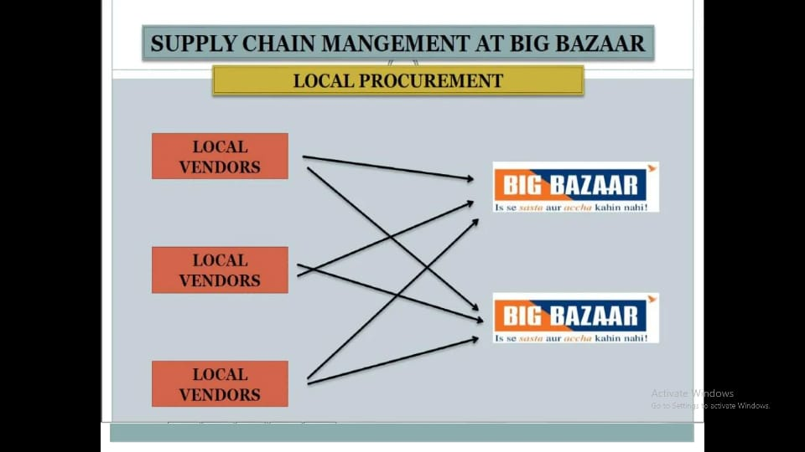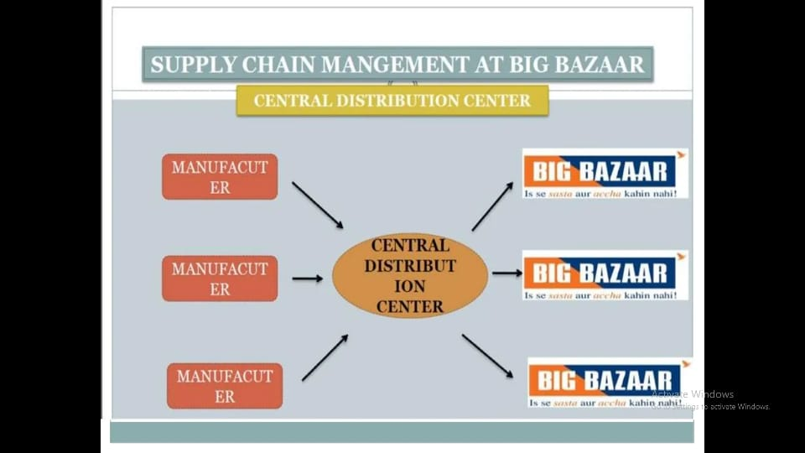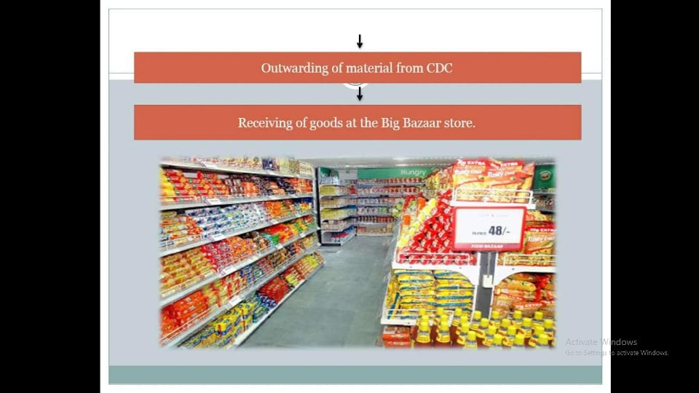

Warehousing at big bazaar

Inward Processing At Warehouse

PO generated by the ARS

↓

Received by the Vendor

↓

Vendor delivers the goods

↓

IRN is issued by the warehouse management team

↓

Stock Tally. If stock tally fails than discrepancy note is generated

↓

GRN is issued

↓

Stock is either pilled in the ware house or sent to the floor for sale

Warehouse management

OUTWARDING PROCESS AT WARE HOUSE

Raising of PO to the vendor by the CDC

↓

Delivery of Stock to the CDC

↓

Receiving of the stocks after weighing, counting and generation of IRN

↓

Information is transferred to SAP

↓

Generation of GRN

↓

Stocks pilled stored in the warehouse of CDC

↓

PO generated from stores to CDC